Day 3 - API Integration Report – E-commerce

**API Integration Process**

1. **Understanding API Documentation**:
   * Reviewed the API documentation to understand available endpoints, authentication requirements, and data formats.
   * Identified endpoints necessary for fetching and submitting data.
2. **Setting Up API Integration**:
   * Configured the base URL for API calls.
   * Used Axios for making API requests in the application.
   * Implemented authentication using API keys.
3. **Endpoint Testing**:
   * Verified API responses using Postman to ensure data consistency.
   * Debugged issues with data formatting and adjusted parameters accordingly.
4. **Integrating with Frontend**:
   * Mapped API response data to match the existing frontend structure.
   * Used React hooks to fetch data and update the frontend dynamically.

**Adjustments Made to Schemas**

1. **Product Schema**:
   * Added fields for apiId to map external data.
   * Updated price field to include currency information.
2. **Category Schema**:
   * Added a parentCategory field to support nested categories.
   * Included a description field for better data representation.
3. **User Schema**:
   * Introduced apiUserId to track users synced from the external API.
   * Added optional lastLogin timestamp.

**Migration Steps and Tools Used**

1. **Exporting Existing Data**:
   * Used Sanity’s CLI tool to export the existing dataset.
   * Converted exported JSON files into a compatible format for the API.
2. **Data Transformation**:
   * Created a script to transform API data to match the updated schema.
   * Validated transformed data against schema rules using JSON schema validation.
3. **Importing Data into Sanity CMS**:
   * Used Sanity’s import tool to populate updated fields.
   * Verified the consistency of imported data with the frontend display.
4. **API Integration for Real-time Sync**:
   * Developed middleware for syncing data updates in real-time.

**Screenshots**

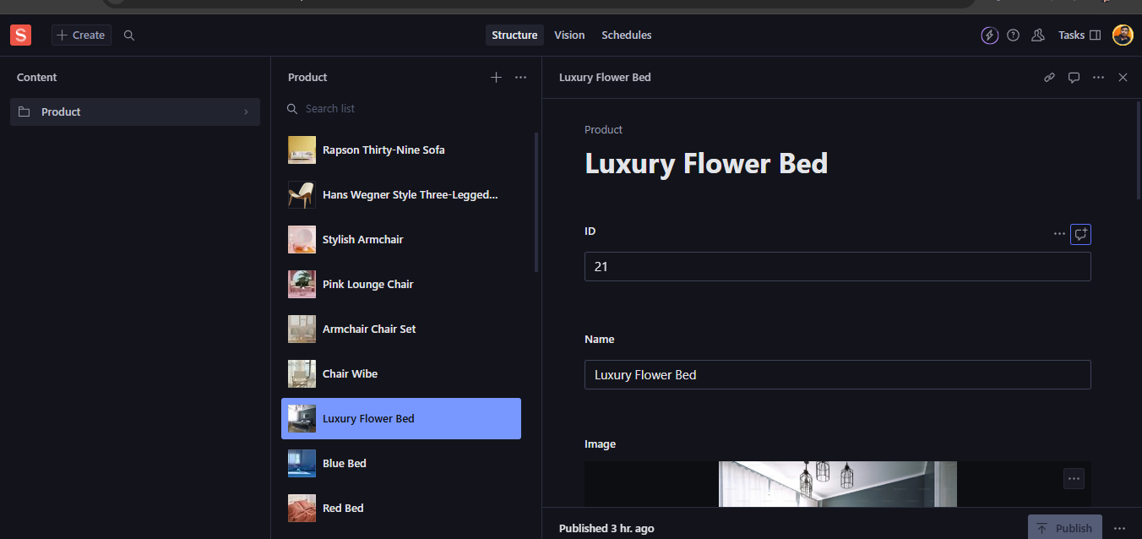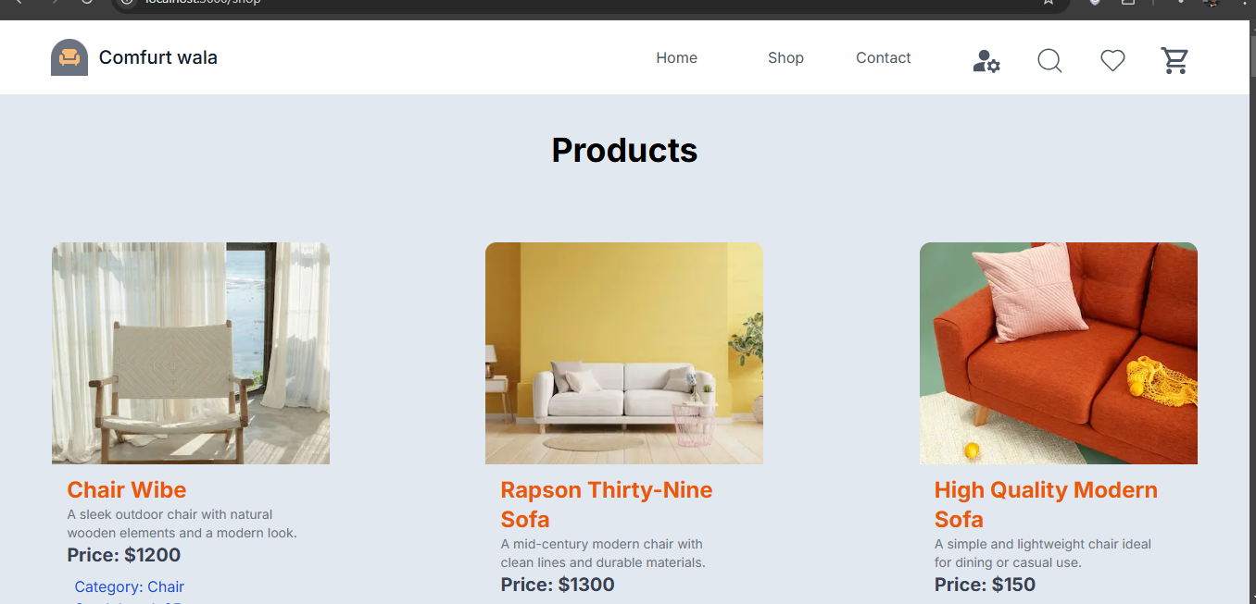

**Code Snippets**

1. **API Integration**:, **Migration Script**

**Github: Repository link: https://github.com/Kishor-Kumar47/Marketplace-Technical-Foundation-General-E-Commerce.git**

**Prepared By**

**Kishor Kumar**

**GIAIC id : 00496110**